
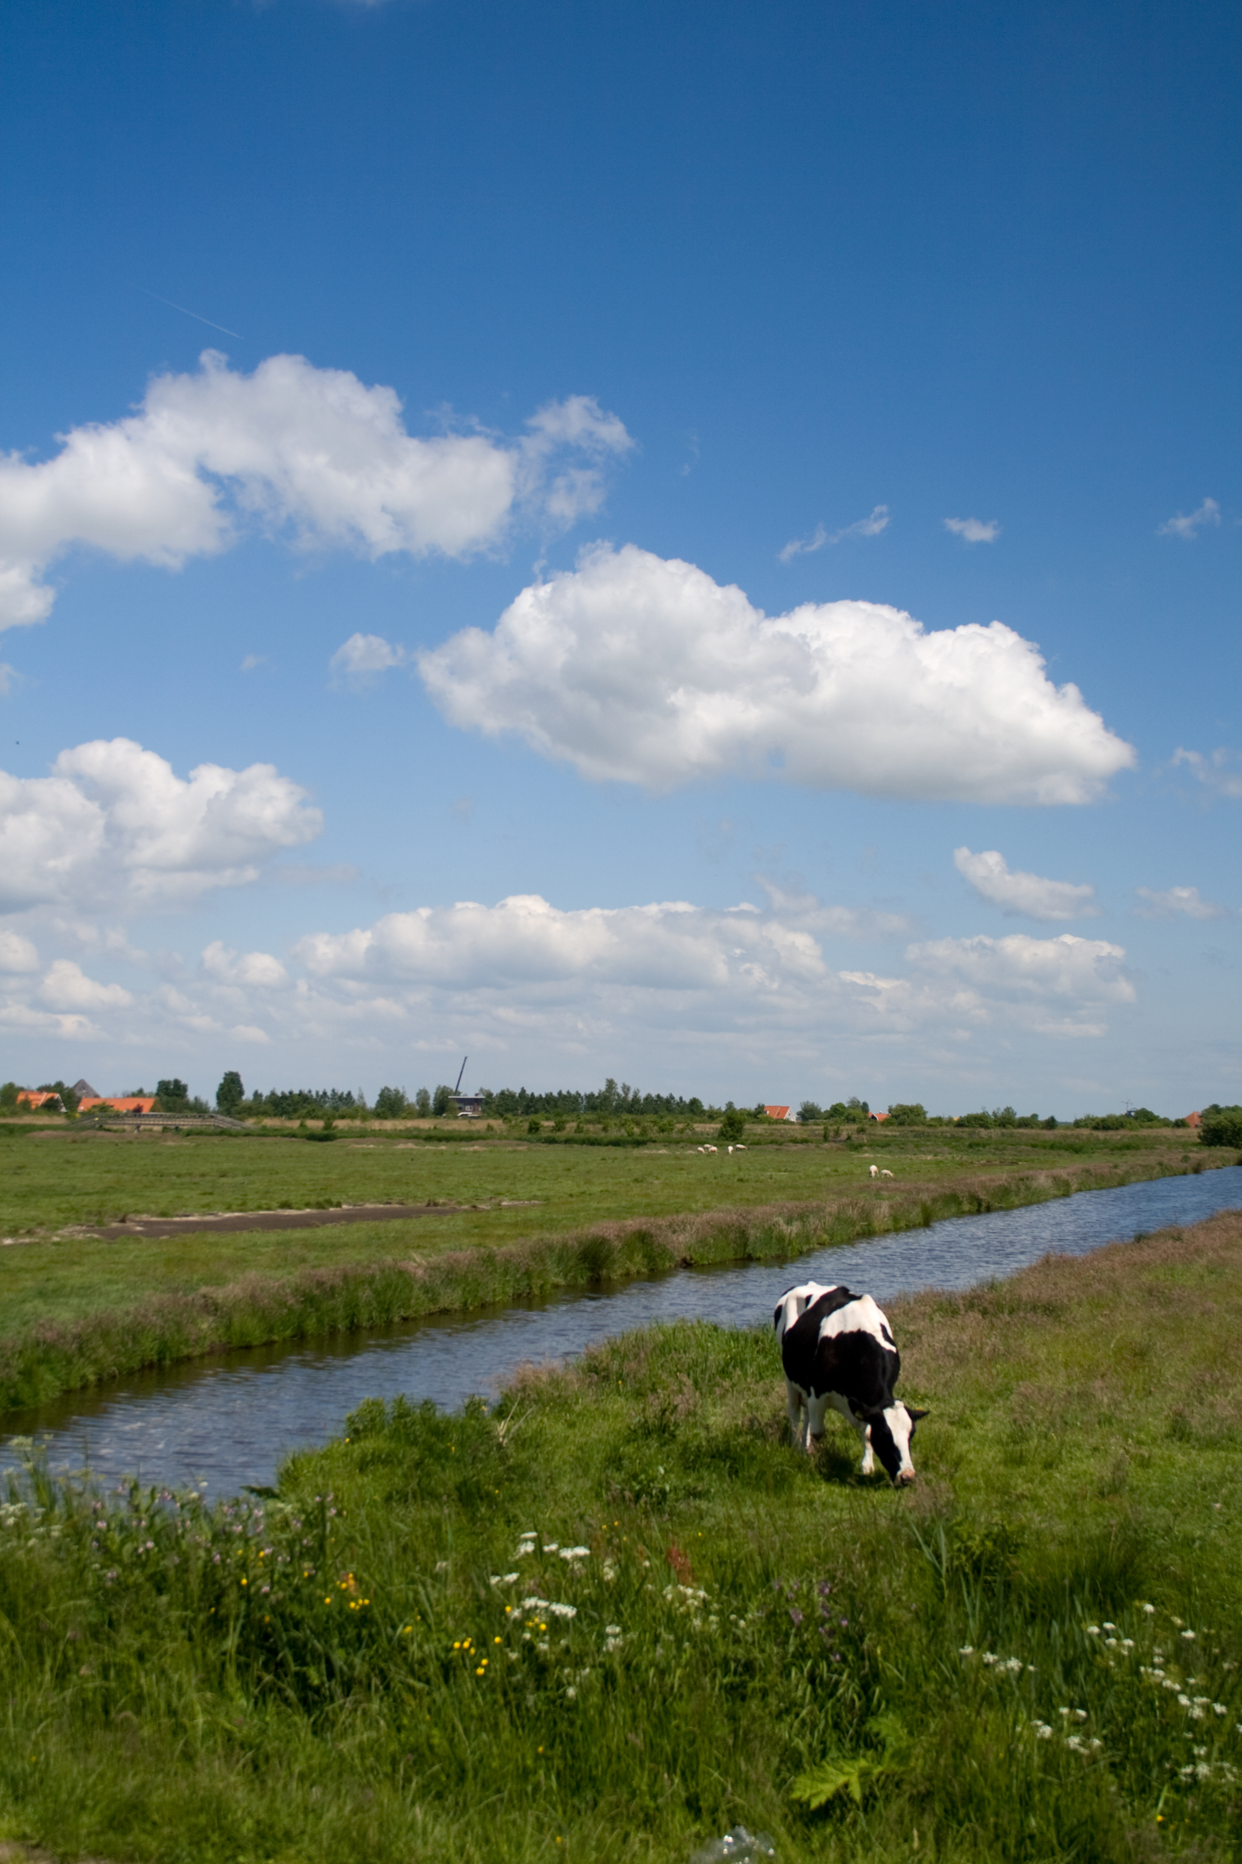


SUMMER SCHOOL

Economics, Management and
Social Sciences:
Their application in

RURAL DEVELOPMENT

Wageningen July 3 – July 11 2009

Subscribe before May 1, 2009

For more information:
www.euroleague-study.org

Wageningen University in collaboration with:
BOKU, Vienna; CULS, Prague; UHOH, Hohenheim; SGGW, Warsaw; LIFE, Copenhagen; SLU, Uppsala

