The cost of participation – 1100 euros.

It includes:
1) Placement in the central hall on the first floor in Ukrainian House – stand of 4 square meters
Construction of an exhibition stand

The standard furniture of an exhibition stand is as follows:
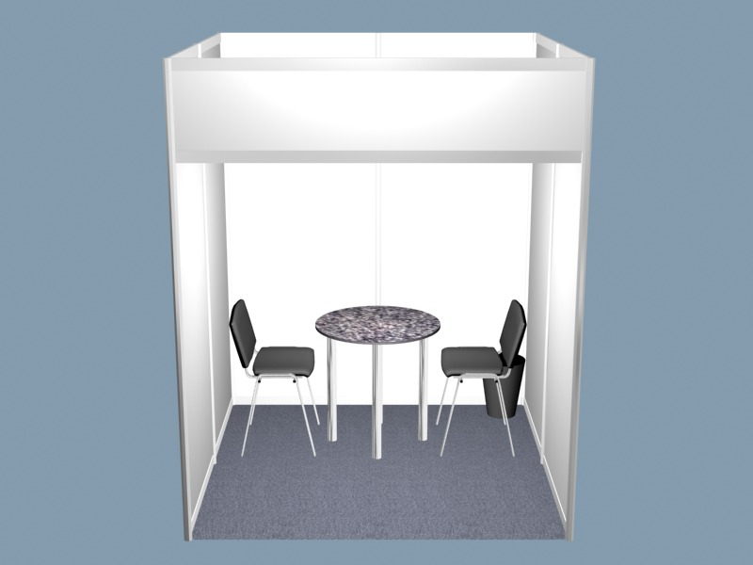
2
- Wall panels (2,5 м – height)
- Signboard with exhibitor’s name.
1
- Table
3
- 2 Chairs
4
- Spot Lamp
- Rubbish bin
- 220 V plug socket

2) information in the fair catalogue (up to 50 words, names and addresses, logo of participant)
3) 30 minutes Power Point Presentation.
4) Invitation for 2 persons to our evening cocktail event.

The cost of participation – 1400 EURO.

It includes:
1) Placement in the central hall on the first floor in Ukrainian House – stand of 6 square meters
Construction of an exhibition stand
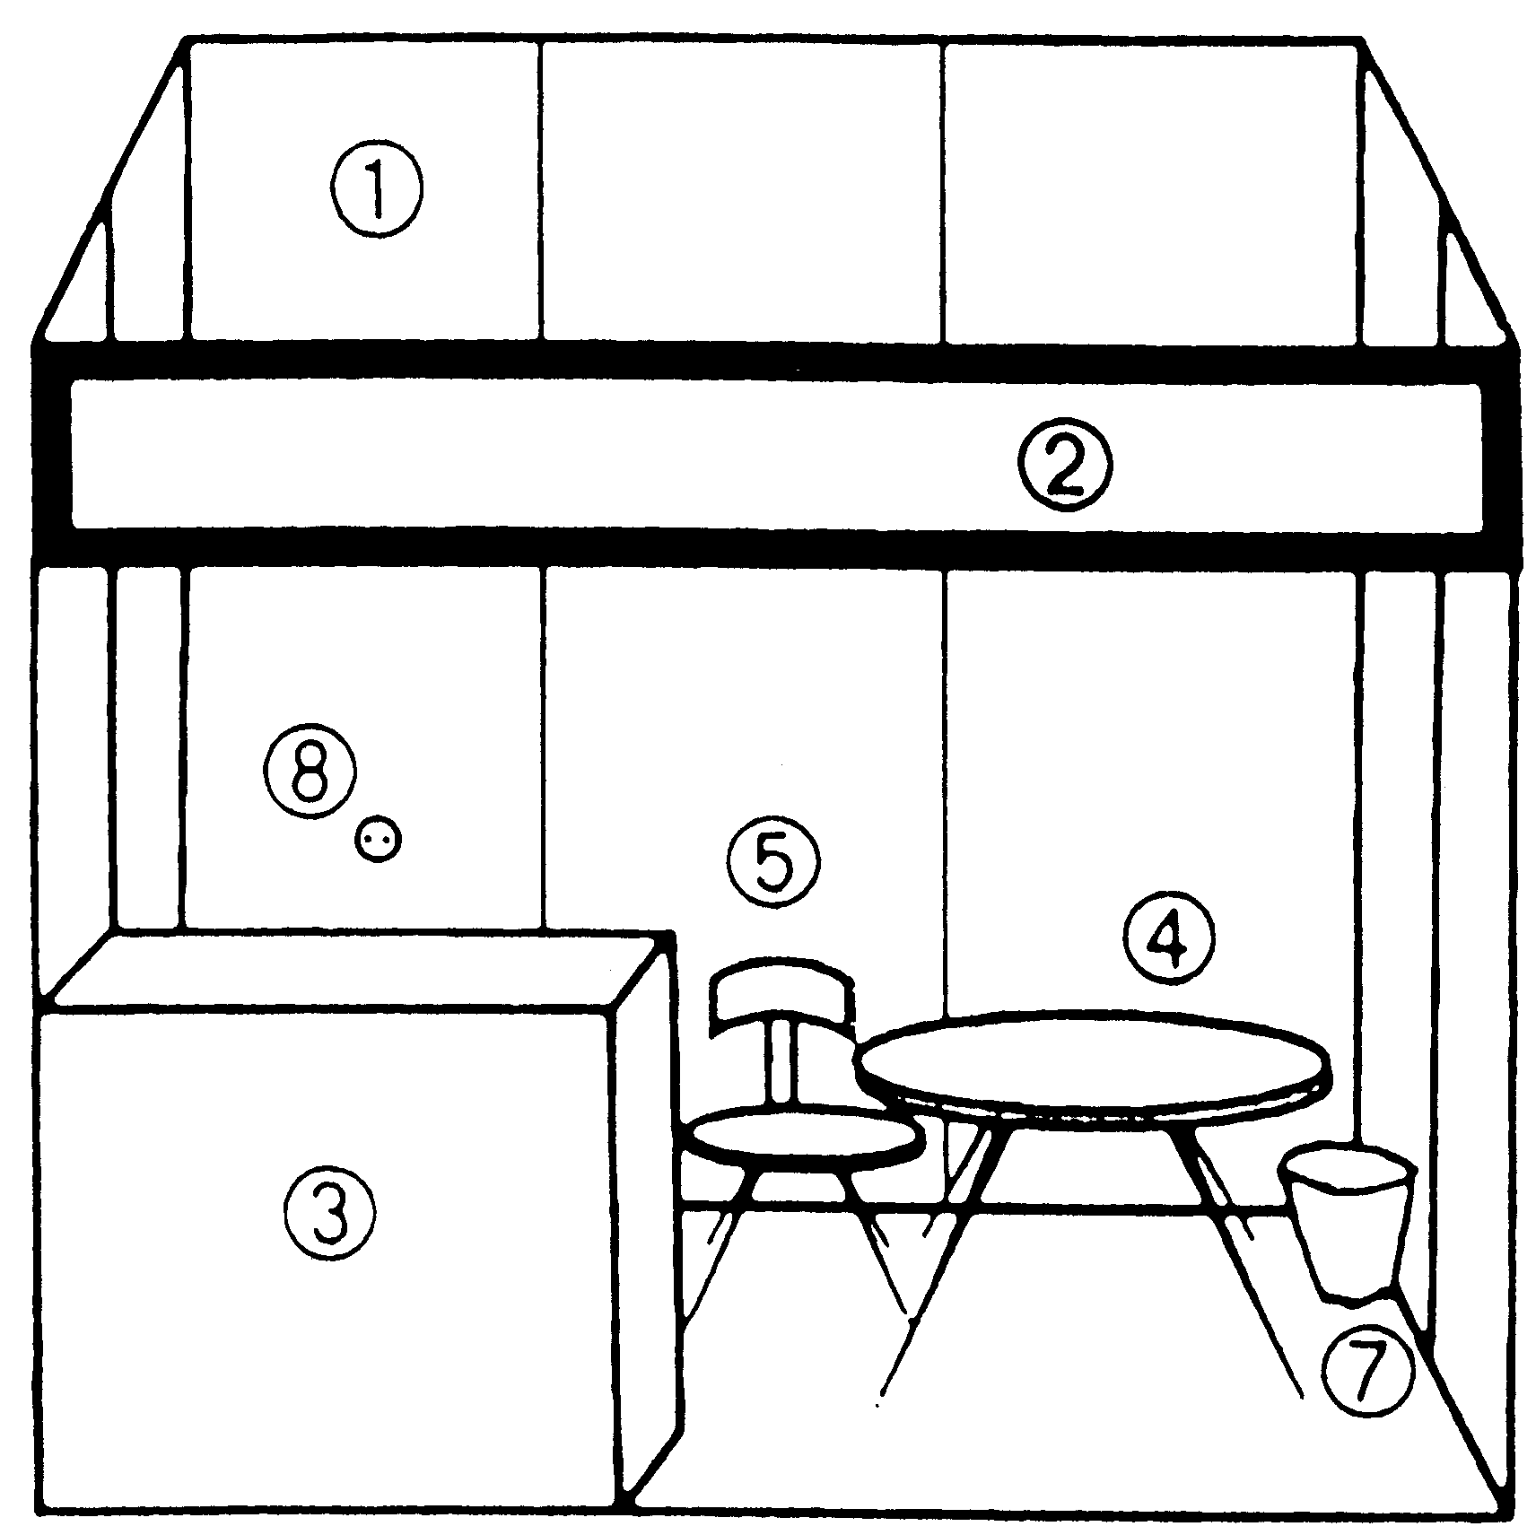
The standard furniture of an exhibition stand is as follows:

- Wall panels (2,5 м – height)
- Signboard with exhibitor’s name
- 1 Counter (1000*500*700 mm)
- Table
- 2 Chairs
- 2 Spot Lamps
- Rubbish bin
- 220 V plug socket

2) information in the fair catalogue (up to 50 words, names and addresses, logo of participant)
3) 30 minutes Power Point Presentation.
4) Invitation for 2 persons to our evening cocktail event.


International Fair «Education abroad»
April 11-13, 2008
Ukrainian House (Khreshchatyk Str.,2)
Ukraine, Kyiv
E-mail: voloshina@znannya.org.ua tel. +38 (044) 237-85-43, 287-37-43
Organization:

Contact Person:

Address:

Tel.: Fax:

E-mail:
¨ Tick necessary (☑) Prices: EURO Attention!!! Prices include VAT and Residence Tax.
We’d like to reserve a fair place measured
¨ Equipped place |  |  |  |  |  | EURO
¨ 4 sq. m ¨ 6 sq. m
Stand identification Sign (please use capital letters)

¨ Distance Participation |  |  |  | 200 |  | EURO

Registration, filing to data base, publication of a standard information block about a participator in the Fair Catalogue
(up to 50 words, plus names and addresses and logo)
¨ Advertisement in Official Fair Catalogue
1 page A5 (145х 210) | ¨ colored. – 250 EURO |  | ¨ black&white – 150 EURO
½ page А 5 (145x 105) | ¨ colored. - 130 EURO |  | ¨ black&white - 80 EURO

¨ Power Point Presentation (30 minutes)
Date  (11th, 12th or 13th of April)) | Time  (from 11.30 a.m. to 18.30 p.m.) | Presentation Name

PRICE FOR ADDITIONAL EQUIPMENT
 | Equipment | Price in EURO
¨ | Table | 20
¨ | Chair | 10
¨ | Counter (1000*500*700 mm) | 35
¨ | Carpet | 15
¨ | Logotype on the Signboard | 30
¨ | Internet | 120
¨ | Plasma screens  Diagonal screen size 42", format 16:9 | 300

¨ Interpreter (Languages ) |  |  |  | 75 | EURO
Total: |  |  |  |  | EURO
Payment Terms: 100% advanced payment.

Prices include VAT and Residence Tax
Payments are performed in compliance with an invoice.

Signature and Stamp __________________ Date________________

